**Practical No: 10**

**Aim: Implement K Nearest Neighbour**

**Code:**

from sklearn.datasets import load_iris

from sklearn.model_selection import train_test_split

from sklearn import metrics

from sklearn.neighbors import KNeighborsClassifier

dataset = load_iris()

x , y = dataset.data,dataset.target

knn = KNeighborsClassifier(n_neighbors = 5)

x_train , x_test , y_train , y_test = train_test_split(x,y , test_size = 0.3,random_state = 42)

print(f"XTrain: {x_train}")

print(f"XTest: {x_test}")

print(f"yTrain: {y_train}")

print(f"y test:{y_test}")

knn.fit(x_train,y_train)

y_pred = knn.predict(x_test)

print(f"y_pred:{y_pred}")

accuracy = metrics.accuracy_score(y_test,y_pred)

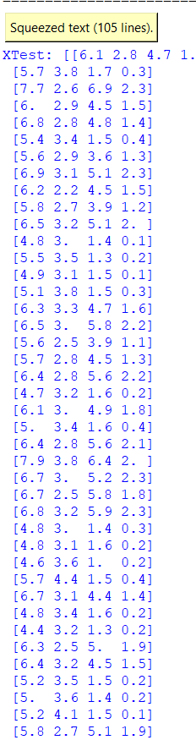print(f"Accuracy :{round(accuracy*100,2)}%")

cm = metrics.confusion_matrix(y_test,y_pred)

print("Confusion Matrix")

print(cm)

**Output**:

